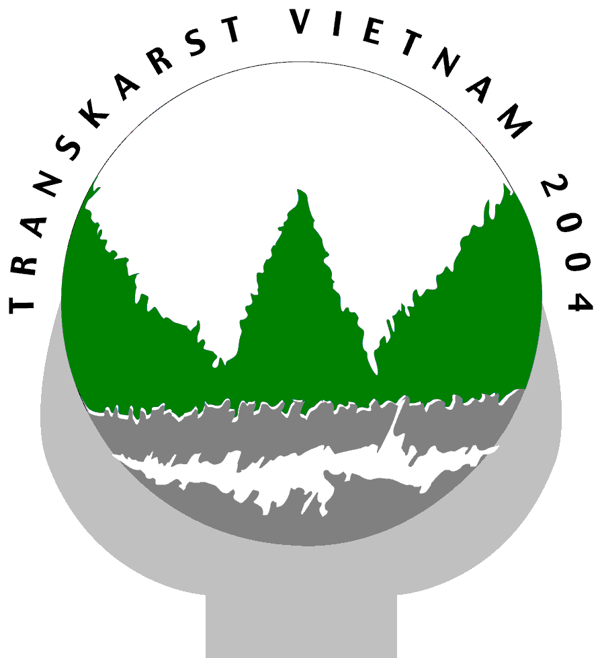 | Trans-KARST 2004
 | International Transdisciplinary Conference on Development and Conservation of Karst Regions

PROCEEDINGS

Organized by
Research Institute of Geology and Mineral Resources (RIGMR)
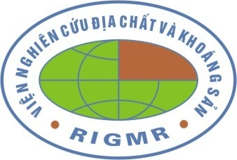

Under the auspices of UNESCO | Under the patronage of the UIS
(IGCP Project 448 and IHP) | (Union Internationale de Speleologie)

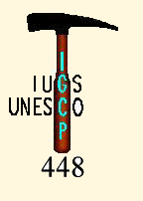

With the support of:
Flemish Interuniversity Council (VLIR), Belgium
Catholic University Leuven (KUL), Belgium
Vrije Universiteit Brussel (VUB), Belgium
Royal Belgian Institute of Natural Sciences, Geological Survey of Belgium (GSB)
Fauna & Flora International (FFI), Vietnam
International Union for Conservation of Nature (IUCN)
International Association of Hydrogeologists (IAH)

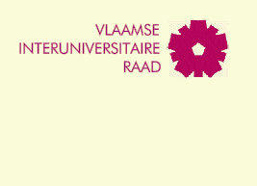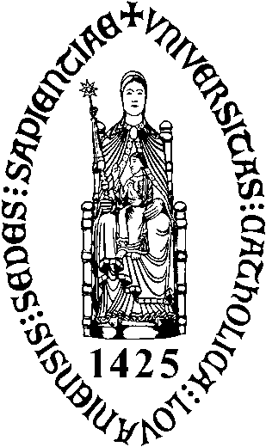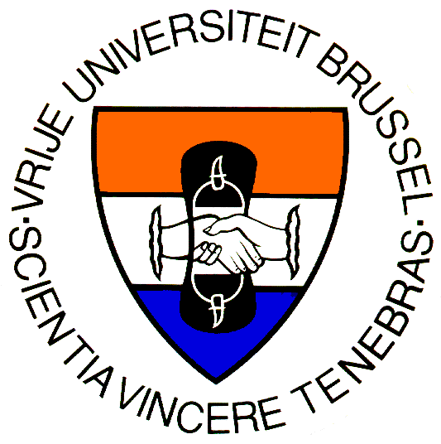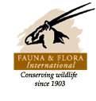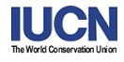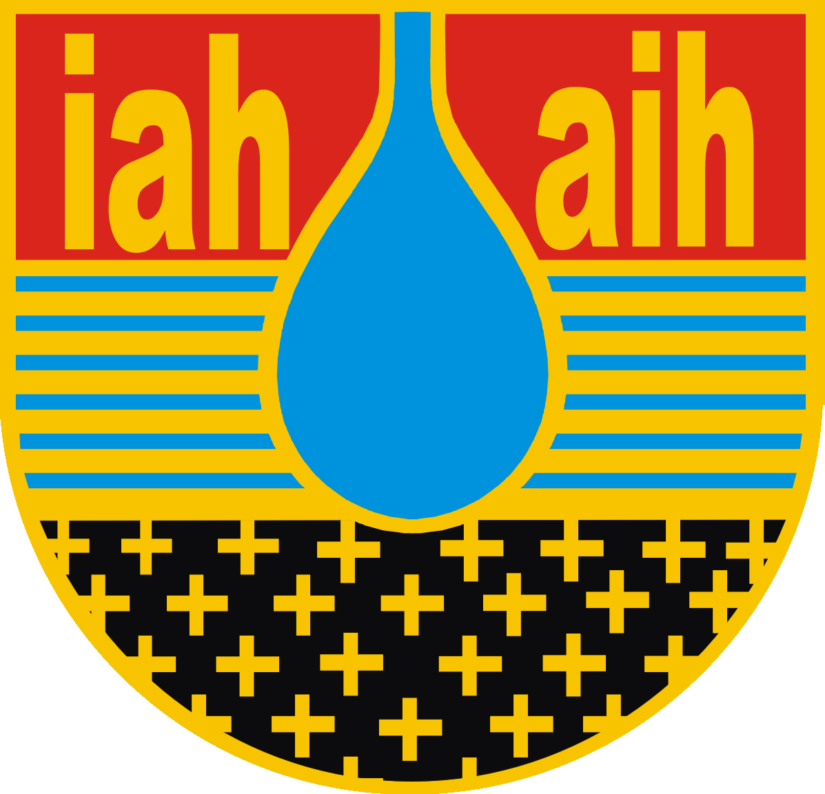

Hanoi, Vietnam | 13 - 18 September 2004

